**volume types deep dive:**

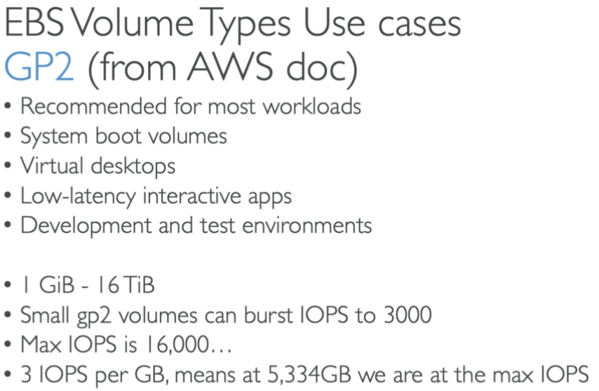

* It is general purpose and it is cheap.
* We get 3 IOPS per GiB with minimum of 100 IOPS, if we create a volume with 400 GB, we get 1200 IOPS. If we give 1 GB, we get minimum IOPS which is 100.

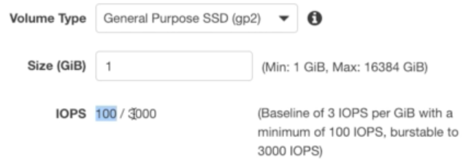

* If we go for 1000 GiB, we get 3000 IOPS and there won’t be burst after that. Burst happens if IOPS is less than 3000

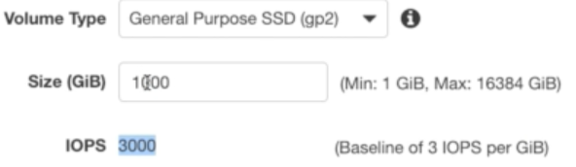

* The maximum IOPS is 16000. If the volume size is bigger than 5333 GiB, then the maxium IOPS we get is 16000. Not more than that

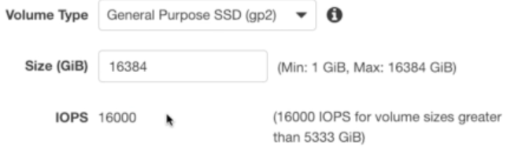

* The next powerful one is IOI.

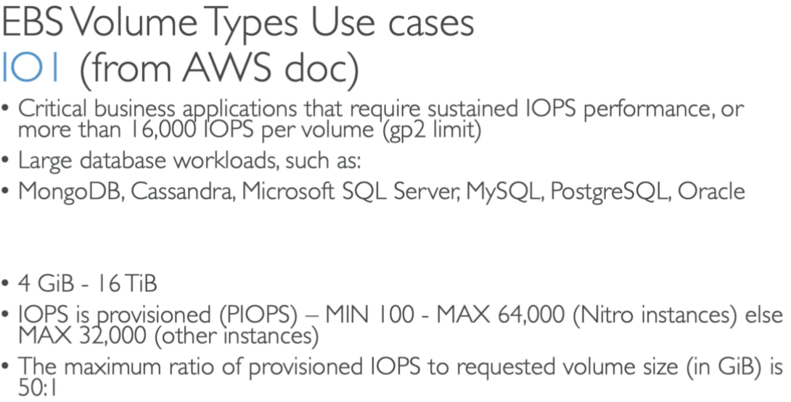

* We get 50 IOPS for each GiB.

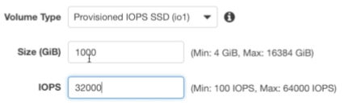

* Here, we can give the IOPS which ever we want as above
* But it cannot be more than 50 per GiB as below.

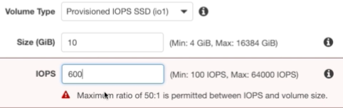

* The next one is ST1 which is less popular.

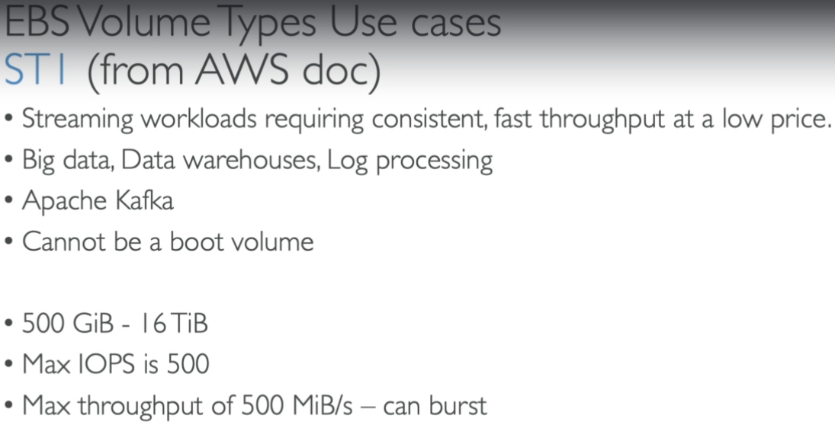

* Maximum throughputs here is 500 for 16000 GiB as below.

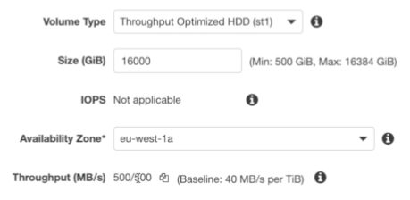

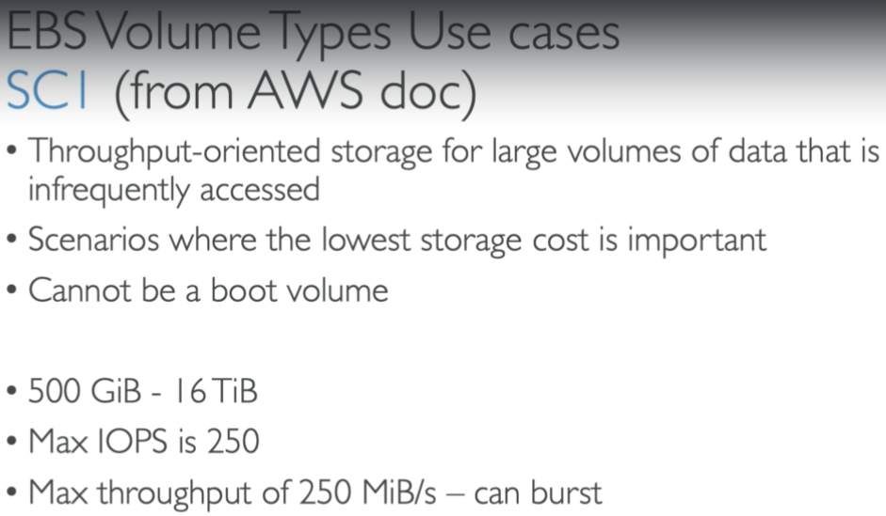

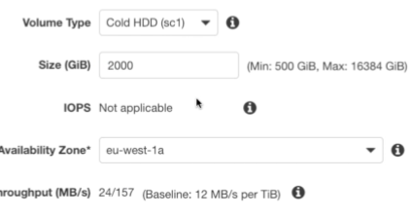

**Summary:**

